TELEMETRY  PIEZOMETERS/ DWLR/ AWLR  (Option: Battery Operated)  - Pressure Transducer Type  - Ultrasonic Sonar Based battery Operated  - Laser Type  are often placed in boreholes to monitor the pressure or depth of ground water. Made of SS material not effected by normal chemical corrosion. | 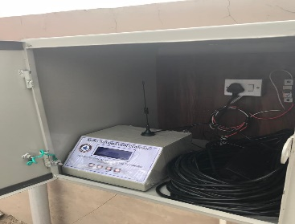 | 1
CASAGRAND POROUS TUBE PIEZOMETER  for pore water pressure measurement of (Ash Dykes,Dams) | 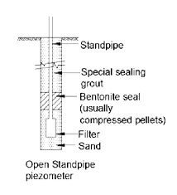 | 2
TELEMETRY  (Option: Battery Operated)  ELECTROMEGNETIC DIGITAL WATER FLOW METER  Of Sizes (25 NB-200 NB)  &  ULTRASONIC Open Channel WATER Level & FLOW Sensor | 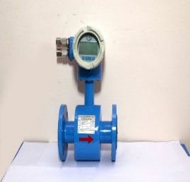  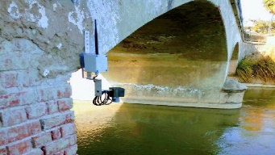 | 3
CLAMP ON WATER FLOW METER | 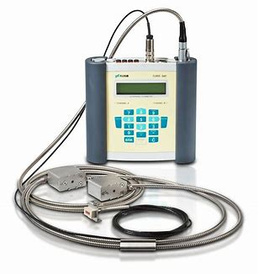 | 4
Non-nuclear Online Density Meter for Iron Ore Slurry | 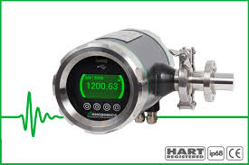 | 5
ON Line  Automatic Weather Station  For Agri & Other Environment research Purposeses | 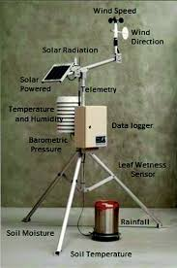 | 6
Hydrogeological & Hydrological studies
Supply of all kinds of Hydrological & Hydrometeorological instrument | 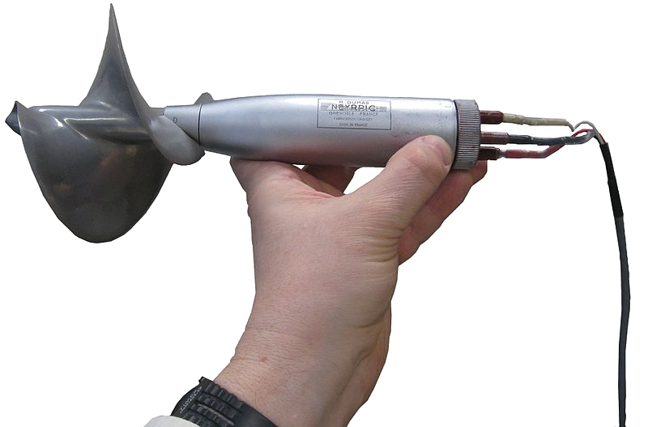 | Z
WATER LEVEL SOUNDER  Water detection un it and Measuring Tape Real marked in meters of sizes (30,50,150,200,300) | 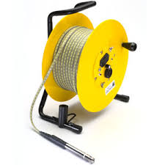 | 7
RESISTIVITY METER  Geophysical equipment for groundwater exploration | 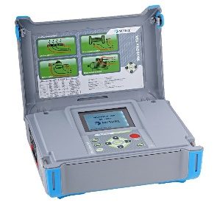 | 8
Stand Pipe/Casagrand Piezometer  Measuring pore pressures in ground.  Pore pressure has fundamental importance to understanding ground behaviour, before—during—and after construction. | 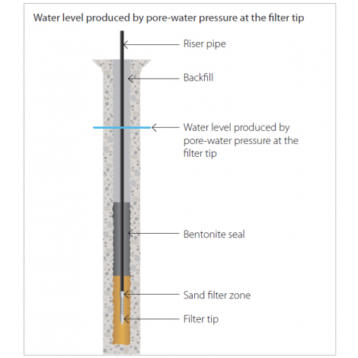
GPR Ground Penetrating Radar Services nd Penetrating (GPR) has been widely used as a nondestructive tool for the investigation of the subsurfaceRa | 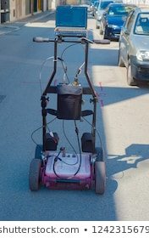
Telemetry  Piezometer/DWLR for On-Line Monitoring of Ground water level  (Supply,Installation & Commissioning  (As per CGWA Guidelines) | 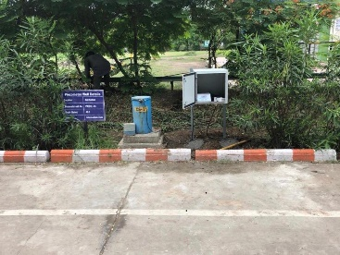 | OK
Impact Assessment Report Preparation & submission for Industries abstracting ground water (100 KL/day)  (As per CGWA Guidelines) |  | OK
Telemetry  Digital Electromagnetic /Ultrasonic Flow Meter  Monitoring Ground water Abstraction Volume  (As per CGWA Guidelines) | 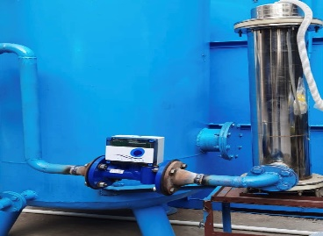 | OK
Telemetry  Ultrasonic Level/Flow Measuring System  For Dams/Canals/Rivers | 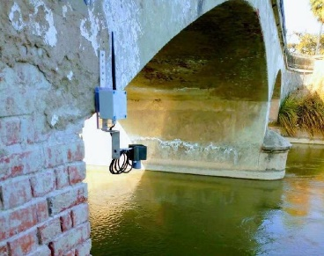 | OK
Modular Rain Water Harvesting  Preparation of Proposal, Supply, Installation & Commissioning of RWH System on Turn Key Basis  (Polymer System) | 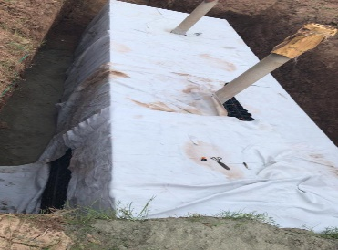 | OK
A wireless weather station with a versatile sensor suite that combines our rain collector, temperature and humidity sensors and anemometer into one package | 